

**Return Patient Intake – Female**

Name:

Date of Birth: Age:

Pain Location:

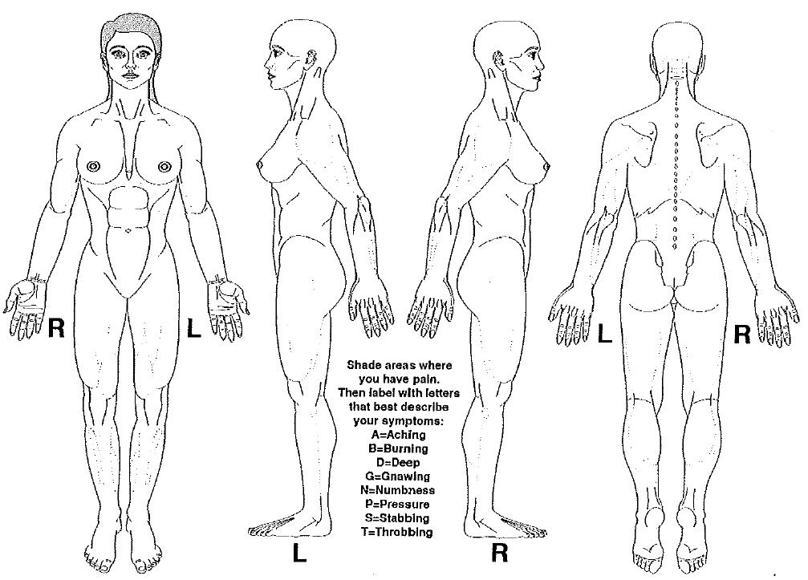

**Pain Description**

Since last seen, your pain has: ⬜ Increased ⬜ Decreased ⬜ Remained the same

What best describes your pain? ⬜ Constant ⬜ Intermittent

When is your pain worst? ⬜ Morning ⬜ Daytime ⬜ Evening ⬜ Night

What makes your pain better?

What makes your pain worse?

**Pain Score**

Pain score now: 0 1 2 3 4 5 6 7 8 9 10

Average pain score, last 24 hours: 0 1 2 3 4 5 6 7 8 9 10

Average pain score, last 3 months: 0 1 2 3 4 5 6 7 8 9 10

How many times per day (24-hour period)

do you need to take medication for pain? 0 1 2 3 4 5 6 7 8 9 10

In the past three months, have you developed any of the following?

⬜ Balance problems ⬜ Difficulty walking ⬜ New numbness

⬜ Bladder incontinence ⬜ Bowel incontinence ⬜ New weakness

**Please indicate if you suffer from any of the following symptoms:**

|  |  |  |  |
| --- | --- | --- | --- |
| **Constitution**  ⬜ Fever/chills  ⬜ Weight loss  ⬜ Malaise/fatigue  ⬜ Weakness | **Eyes**  ⬜ Blurred/changes to vision  ⬜ Sensitivity to light  ⬜ Eye pain  ⬜ Eye discharge | **Gastrointestinal**  ⬜ Heartburn  ⬜ Nausea  ⬜ Vomiting  ⬜ Abdominal pain  ⬜ Diarrhea  ⬜ Constipation  ⬜ Incontinence of stool | **Hematology**  ⬜ Easy bruising  ⬜ Easy bleeding  ⬜ Blood clots |
| **Skin**  ⬜ Rash  ⬜ Itching | **Cardiovascular**  ⬜ Chest pain  ⬜ Palpitations  ⬜ Ankle/leg swelling  ⬜ Difficulty breathing when lying flat | **Genitourinary**  ⬜ Painful urination  ⬜ Blood in urine  ⬜ Flank pain  ⬜ Incontinence of urine | **Neurological**  ⬜ Dizziness/ lightheadedness  ⬜ Headaches  ⬜ Tingling  ⬜ Tremor  ⬜ Sensory change  ⬜ Focal weakness  ⬜ Seizures |
| **Ears/Nose/Throat**  ⬜ Hearing loss  ⬜ Ear pain  ⬜ Nose bleeds  ⬜ Sinus pain  ⬜ Sore throat  ⬜ Dry mouth | **Respiratory**  ⬜ Cough/cold  ⬜ Sputum production  ⬜ Shortness of breath  ⬜ Wheezing | **Musculoskeletal**  ⬜ Muscle pains  ⬜ Neck pain  ⬜ Back pain  ⬜ Joint pain  ⬜ Recent falls  ⬜ Loss of height | **Psychiatric**  ⬜ Depression  ⬜ Suicidal thoughts  ⬜ Hallucinations  ⬜ Anxiety  ⬜ Difficulty sleeping  ⬜ Memory loss |

Other:

Signature: Date: Time: