

**New Patient Intake – Male**

Name:

Date of Birth: Age:

Preferred Phone:

Secondary Phone:

Email:

Primary Care Physician: Phone:

Referring Physician: Phone:

Preferred Pharmacy: Phone:

Pain Location: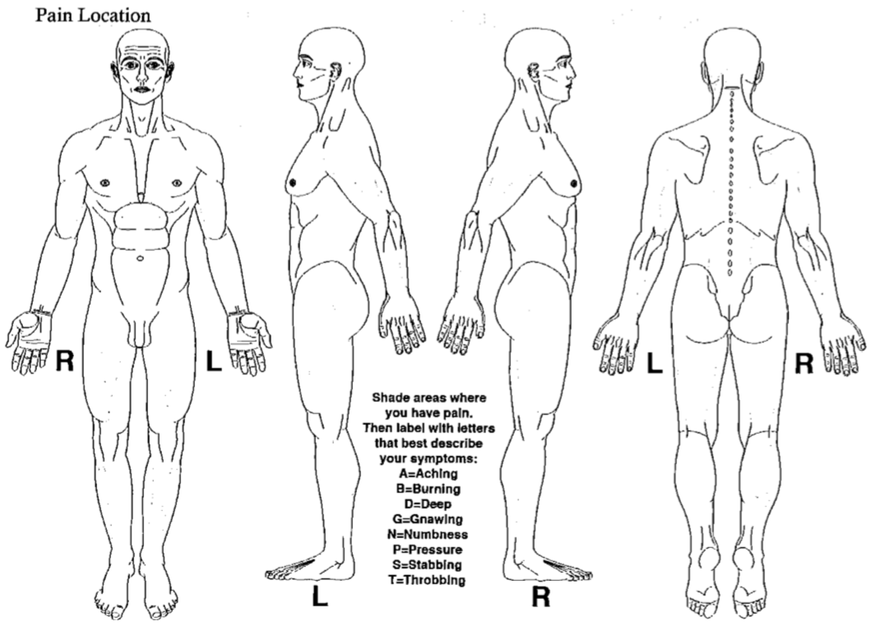

**Pain Description**

When and how did your pain start?

What is your understanding of what is causing your pain?

What makes your pain better?

What makes your pain worse?

Since your pain began, it has: ⬜ Increased ⬜ Decreased ⬜ Remained the same

What best describes your pain? ⬜ Constant ⬜ Intermittent

When is your pain worst? ⬜ Morning ⬜ Daytime ⬜ Evening ⬜ Night

In the past three months, have you developed any of the following?

⬜ Balance problems ⬜ Difficulty walking ⬜ New numbness

⬜ Bladder incontinence ⬜ Bowel incontinence ⬜ New weakness

**Pain Score**

Pain score now: 0 1 2 3 4 5 6 7 8 9 10

Average pain score, last 24 hours: 0 1 2 3 4 5 6 7 8 9 10

Average pain score, last 3 months: 0 1 2 3 4 5 6 7 8 9 10

**Working / Daily Activities**

If employed, what type of job do you work?

How much does your pain interfere with your ability to do work?

⬜ No Interference ⬜ Moderate Interference ⬜ Extreme Interference

How much does your pain interfere with your daily activities?

⬜ No Interference ⬜ Moderate Interference ⬜ Extreme Interference

Are you on disability? ⬜ Yes ⬜ No

Do you have a worker’s compensation claim? ⬜ Yes ⬜ No

Are you currently involved in a lawsuit? ⬜ Yes ⬜ No

**Diagnostic Tests Completed:**

⬜ X-Rays ⬜ CT Scans ⬜ MRI

⬜ Bone Scan ⬜ Discogram ⬜ EMG, nerve conduction studies

⬜ Myelogram ⬜ Other:



**New Patient Intake – Male**

Name:

**Medications Tried:**

⬜ Benzodiazepines ⬜ Cymbalta *Duloxetine* ⬜ Tylenol *Acetaminophen* ⬜ Ultram *Tramadol*

⬜ Neurontin *Gabapentin* ⬜ Effexor *Venlafaxine* ⬜ Namenda *Memantine* ⬜ Lortab *Hydrocodone*

⬜ Lyrica *Pregabalin* ⬜ Savella *Milnacipran* ⬜ Mexitil *Mexiletine* ⬜ Percocet *Oxycodone*

⬜ Topamax *Topiramate* ⬜ Advil *Ibuprofen* ⬜ Lidocaine patch ⬜ Morphine

⬜ Trileptal *Oxcabazepine* ⬜ Aleve *Naproxen* ⬜ Baclofen ⬜ Methadone

⬜ Tegretol *Carbamazepine* ⬜ Mobic *Meloxicam* ⬜ Zanaflex *Tizanidine* ⬜ Dilaudid *Hydromorphone*

⬜ Elavil *Amitriptyline* ⬜ Celebrex *Celecoxib* ⬜ Flexeril *Cyclobenzaprine* ⬜ Fentanyl

⬜ Norpramin *Desipramine* ⬜ Voltaren *Diclofenac* ⬜ Skelaxin *Metaxalone* ⬜ Suboxone

⬜ Pamelor *Nortriptyline* ⬜ Aspirin ⬜ Robaxin *Methocarbamol* ⬜ Butrans *Buprenorphine*

⬜ Other:

**Procedures Tried:**

⬜ Trigger point injection ⬜ Bursa injection ⬜ Genicular nerve block/ablation

⬜ Piriformis injection ⬜ Sacroiliac joint injection ⬜ Sympathetic nerve block

⬜ Psoas injection ⬜ Epidural steroid Injection ⬜ Intrathecal pump

⬜ Hip injection ⬜ Facet joint injection ⬜ Vertebroplasty/kyphoplasty

⬜ Shoulder injection ⬜ Medial branch block ⬜ Interspinous Spacer

⬜ Knee injection ⬜ Radiofrequency ablation ⬜ Spinal cord stimulator

⬜ Other:

**Other Treatments Tried:**

⬜ Physical Therapy ⬜ Acupuncture ⬜ Behavioral modification

⬜ Massage ⬜ Chiropractor ⬜ Biofeedback

⬜ TENS Unit ⬜ Aquatic exercise ⬜ Yoga

⬜ Pilates ⬜ Mindfulness ⬜ Meditation

⬜ Other:

**Medical History:**

Do you take blood thinners or anticoagulants? ⬜ Yes ⬜ No

⬜ Aspirin ⬜ Plavix *Clopidogrel* ⬜ Coumadin *Warfarin* ⬜ Lovenox *Enoxaparin* ⬜ Aggrenox

⬜ Other:

Do you have diabetes? ⬜ Yes ⬜ No

Do you have an implantable device or pacemaker? ⬜ Yes ⬜ No

If yes, what device?

Have you had any recent infections? ⬜ Yes ⬜ No

If yes, what type?

Are you taking antibiotics? ⬜ Yes ⬜ No

**Family History:**

Do you have a family history of alcohol abuse? ⬜ Yes ⬜ No

Do you have a family history of illegal drug use? ⬜ Yes ⬜ No

Do you have a family history of prescription drug abuse? ⬜ Yes ⬜ No

**Social and Psychological History:**

Do you have a personal history of alcohol abuse? ⬜ Yes ⬜ No

Do you have a personal history of illegal drug use? ⬜ Yes ⬜ No

Do you have a personal history of prescription drug abuse? ⬜ Yes ⬜ No

Do you have a history of ADD/ADHD, OCD, bipolar, or schizophrenia? ⬜ Yes ⬜ No

Do you have a history of depression? ⬜ Yes ⬜ No

Do you receive outpatient psychiatric treatment or have you ever been

hospitalized for a psychiatric reason? ⬜ Yes ⬜ No

Have you ever used prescription medications inappropriately? ⬜ Yes ⬜ No

Do you use street drugs? ⬜ Yes ⬜ No

Do you ever have nightmares or flashbacks about traumatic experiences? ⬜ Yes ⬜ No

Do you smoke? ⬜ Yes ⬜ No If yes, how many packs per day?

Are you currently taking any opioid/narcotic medications? ⬜ Yes ⬜ No

If yes, which medication(s)?

**Please indicate if you suffer from any of the following symptoms:**

|  |  |  |  |
| --- | --- | --- | --- |
| **Constitution**  ⬜ Fever/chills  ⬜ Weight loss  ⬜ Malaise/fatigue  ⬜ Weakness | **Eyes**  ⬜ Blurred/changes to vision  ⬜ Sensitivity to light  ⬜ Eye pain  ⬜ Eye discharge | **Gastrointestinal**  ⬜ Heartburn  ⬜ Nausea  ⬜ Vomiting  ⬜ Abdominal pain  ⬜ Diarrhea  ⬜ Constipation  ⬜ Incontinence of stool | **Hematology**  ⬜ Easy bruising  ⬜ Easy bleeding  ⬜ Blood clots |
| **Skin**  ⬜ Rash  ⬜ Itching | **Cardiovascular**  ⬜ Chest pain  ⬜ Palpitations  ⬜ Ankle/leg swelling  ⬜ Difficulty breathing when lying flat | **Genitourinary**  ⬜ Painful urination  ⬜ Blood in urine  ⬜ Flank pain  ⬜ Incontinence of urine | **Neurological**  ⬜ Dizziness/ lightheadedness  ⬜ Headaches  ⬜ Tingling  ⬜ Tremor  ⬜ Sensory change  ⬜ Focal weakness  ⬜ Seizures |
| **Ears/Nose/Throat**  ⬜ Hearing loss  ⬜ Ear pain  ⬜ Nose bleeds  ⬜ Sinus pain  ⬜ Sore throat  ⬜ Dry mouth | **Respiratory**  ⬜ Cough/cold  ⬜ Sputum production  ⬜ Shortness of breath  ⬜ Wheezing | **Musculoskeletal**  ⬜ Muscle pains  ⬜ Neck pain  ⬜ Back pain  ⬜ Joint pain  ⬜ Recent falls  ⬜ Loss of height | **Psychiatric**  ⬜ Depression  ⬜ Suicidal thoughts  ⬜ Hallucinations  ⬜ Anxiety  ⬜ Difficulty sleeping  ⬜ Memory loss |

Other:

Signature: Date: Time: